**EXP 13)**Create a Virtual Hard Disk and allocate the storage using VM ware Workstation

**PROCEDURE:**

**STEP 1:** install VM ware software

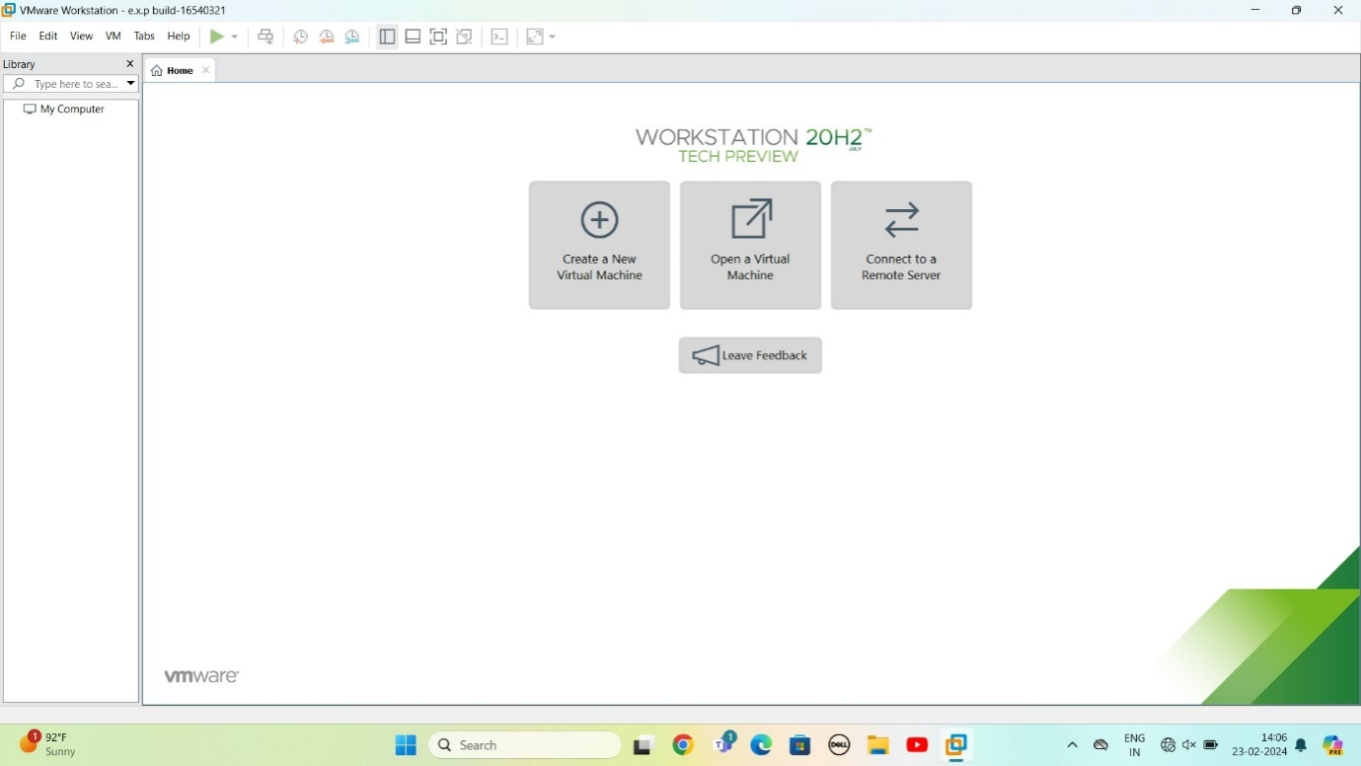

Step 2: CREAT A NEW VIRTUAL MACHINE

GIVE NEXT

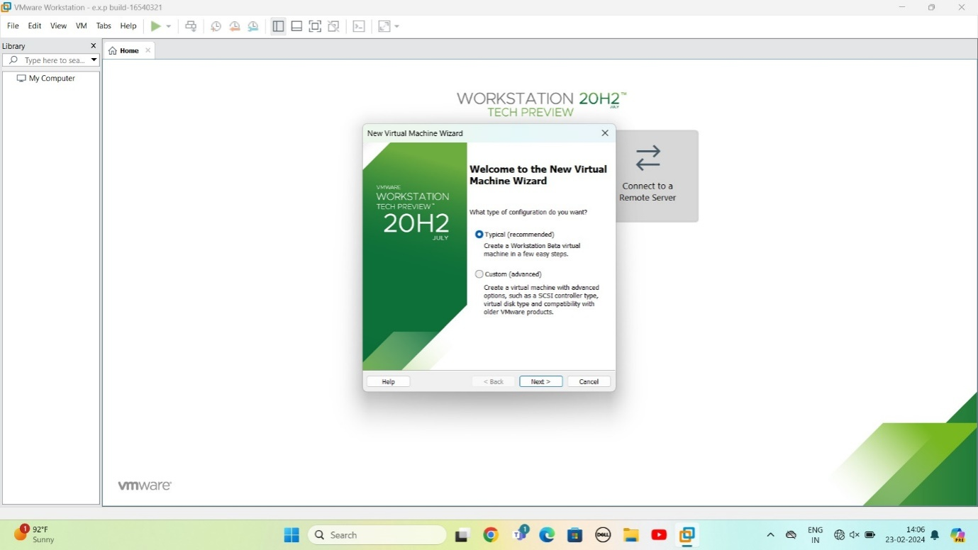

STEP 3: Select I will install operating system later

Give next

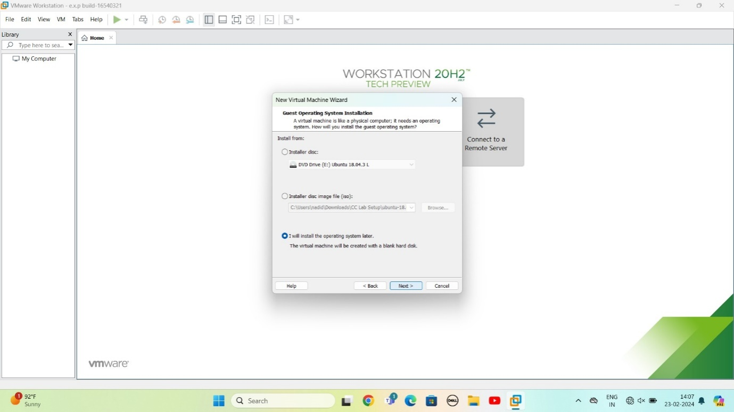

STEP 4: Select gust operating system

Give next

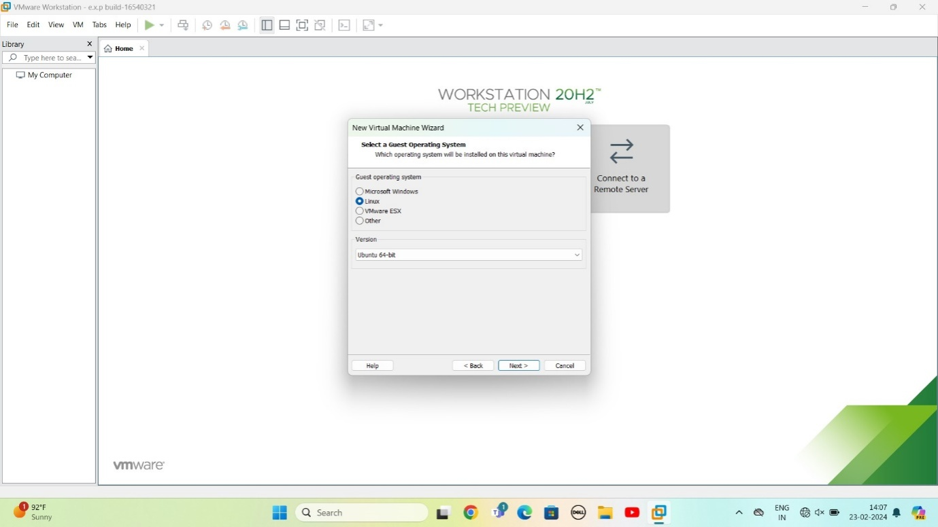

STEP 5: select name of virtual machine

Give next

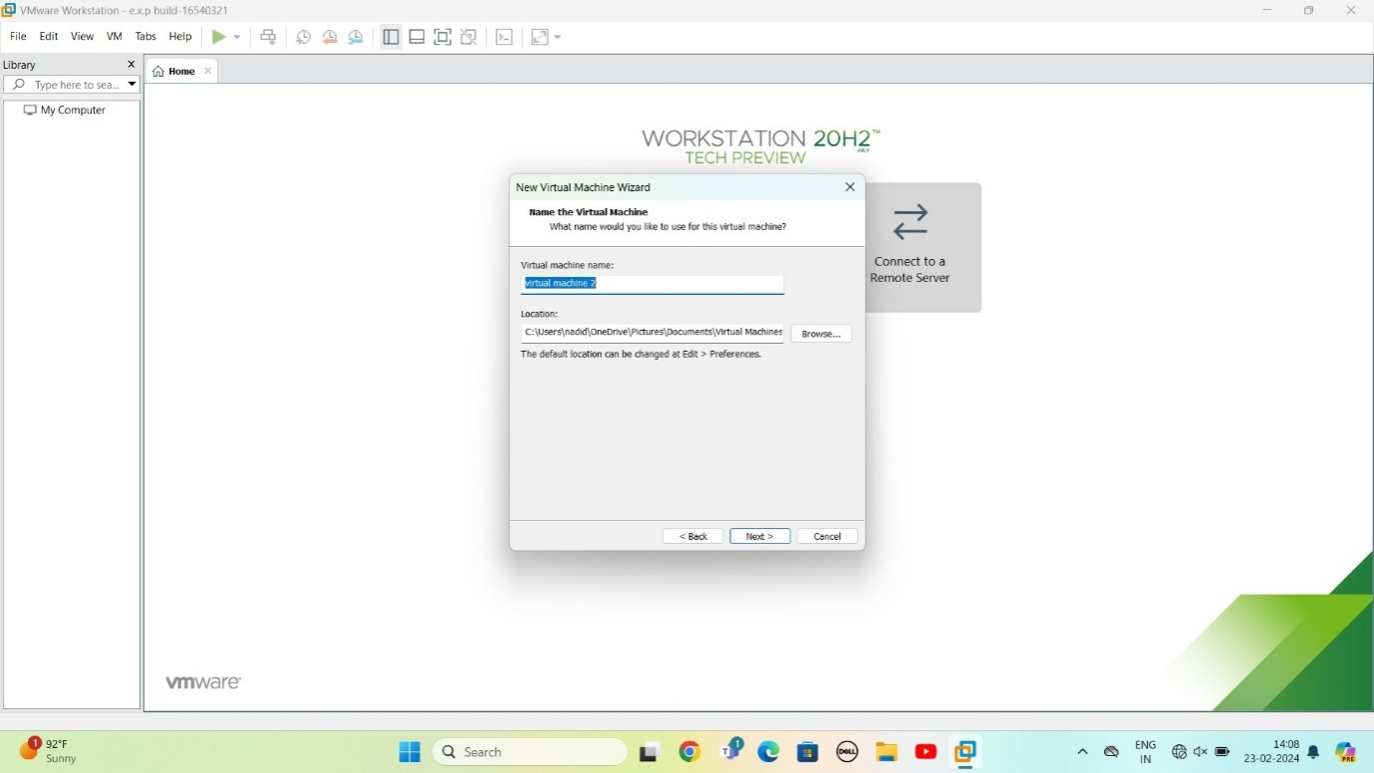

STEP 6: select the data storing disk and maximum size of disk

Give next

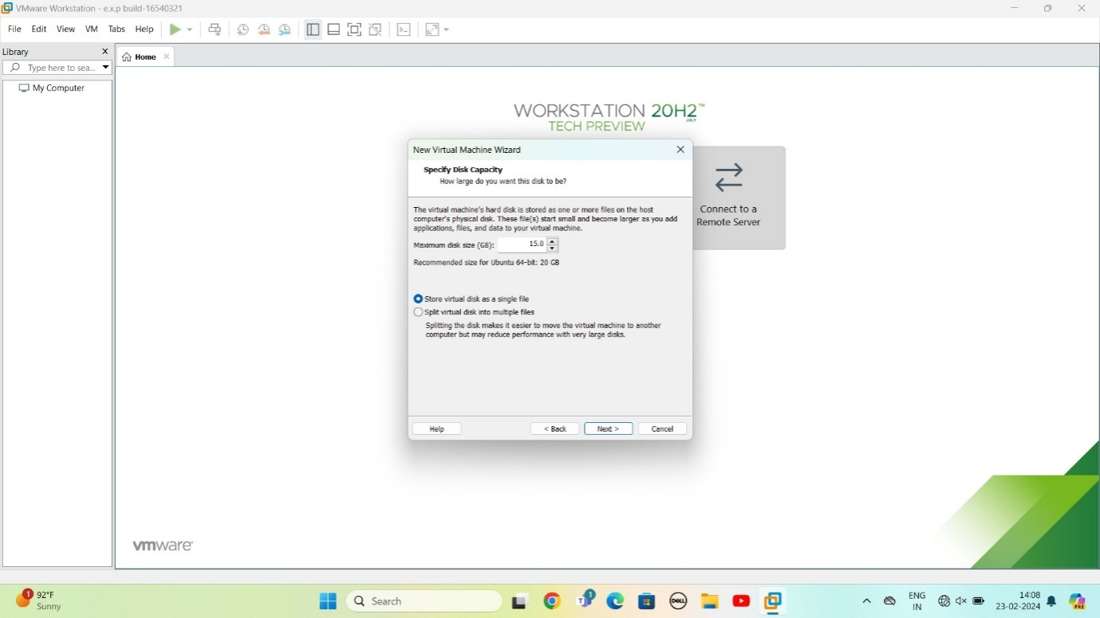

STEP 7:Ready to create virtual machine

Give finish

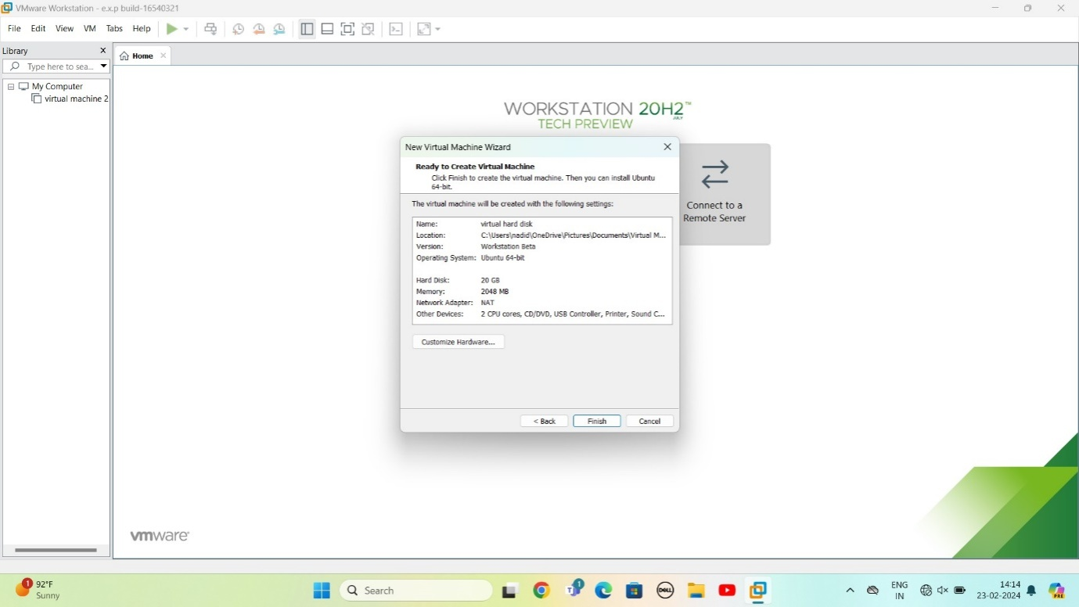

STEP 8: created the virtual machine

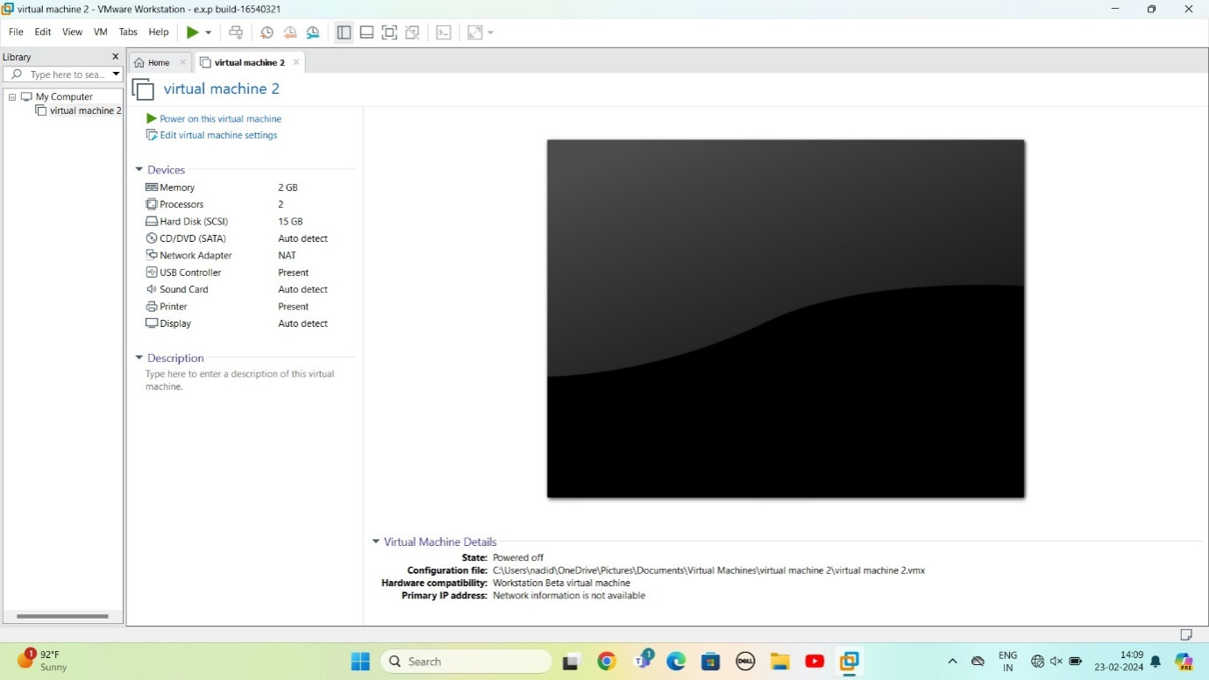

STEP 9:Create a Virtual Hard Disk and allocate the storage using VM ware Workstation

Goto edit virtual machine

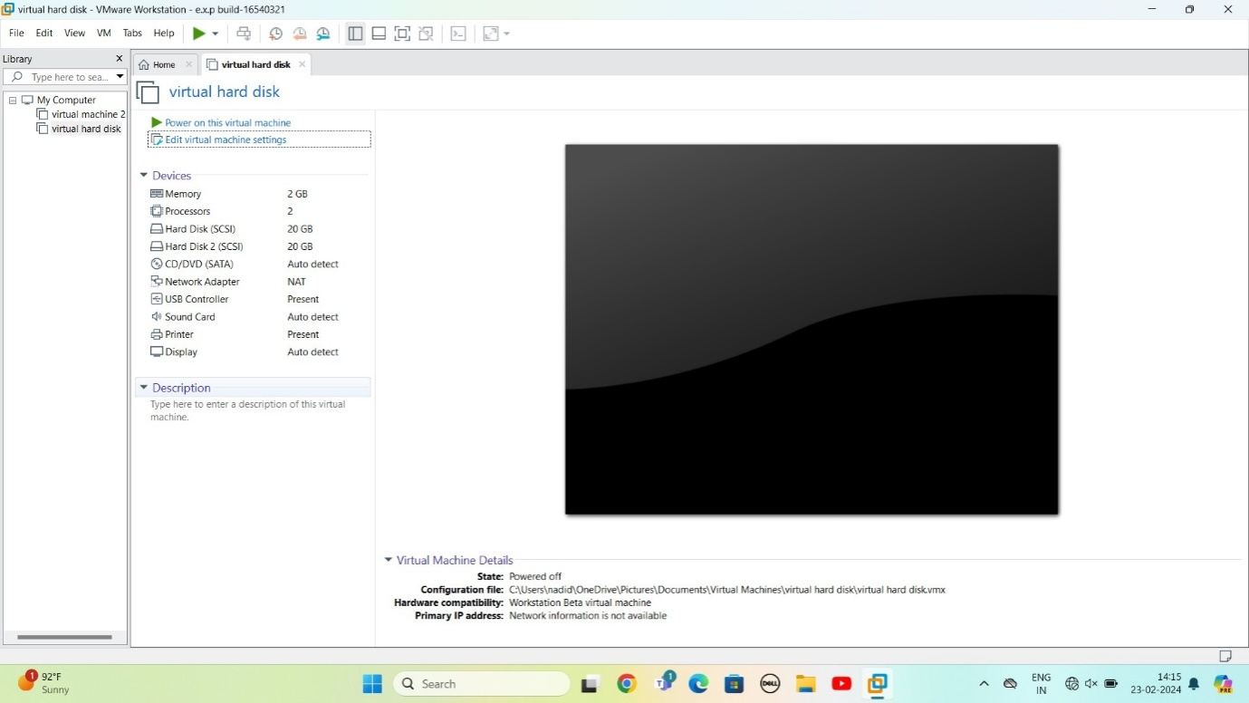

STEP 10: Click on add

Select hard disk

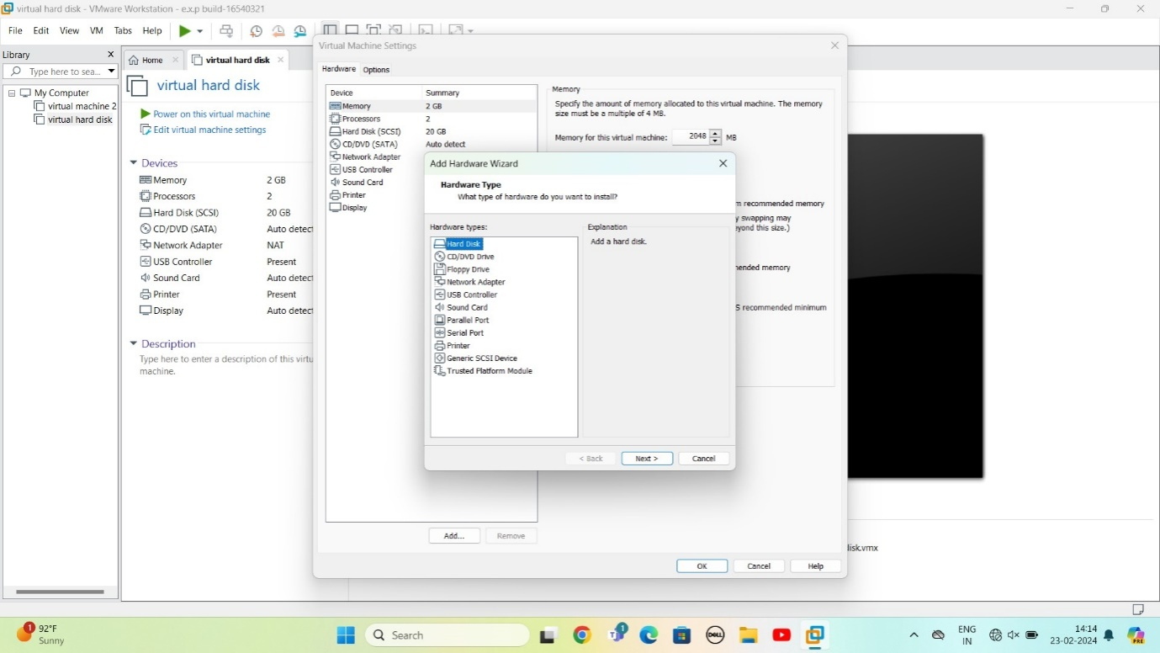

STEP 11: select disk type

Give next

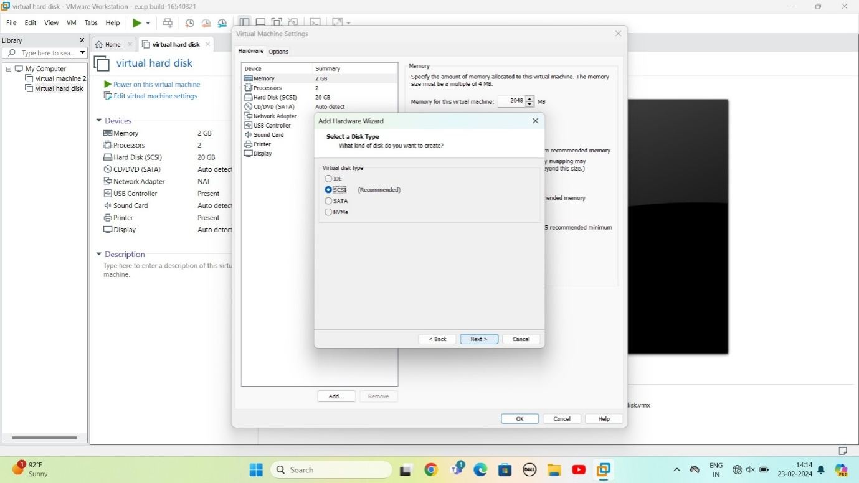

STEP 12: select create a new virtual machine

Give next

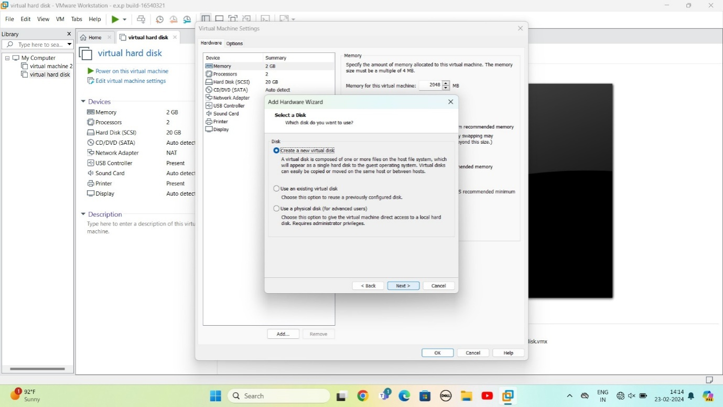

STEP 13: select the data storing disk and maximum size of disk

Give next

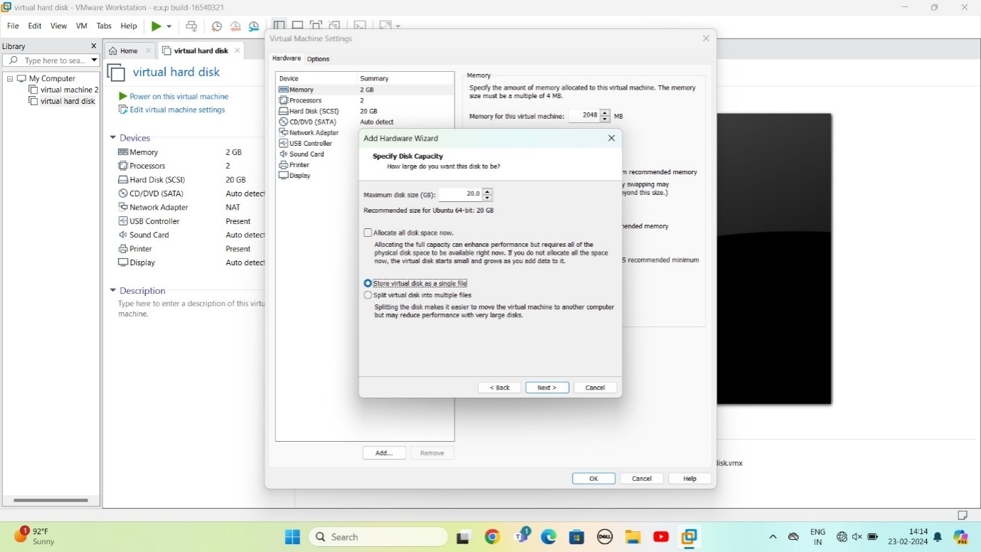

STEP 14: it’s ready to create duplicate hard disk

Give finish

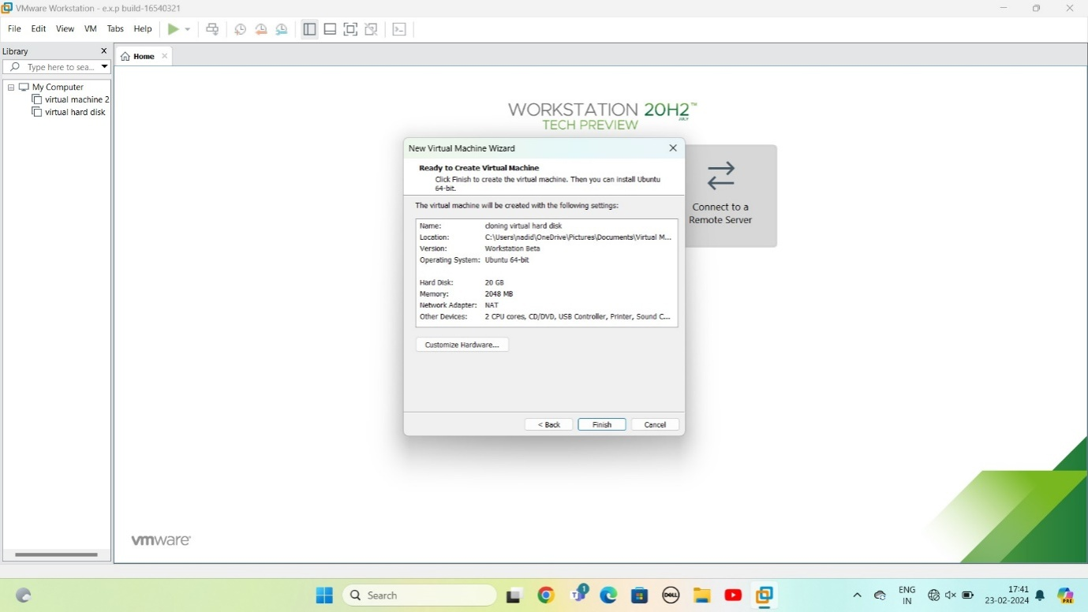

STEP 15: virtual hard disk ready

Give ok

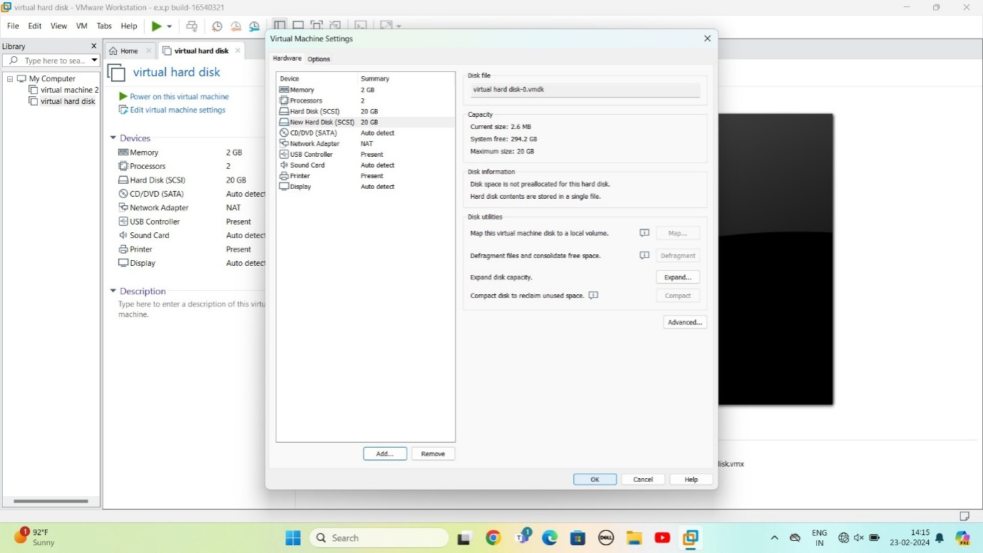

STEP 16: AS per question Virtual Hard Disk and allocate the storage using VM ware ready

